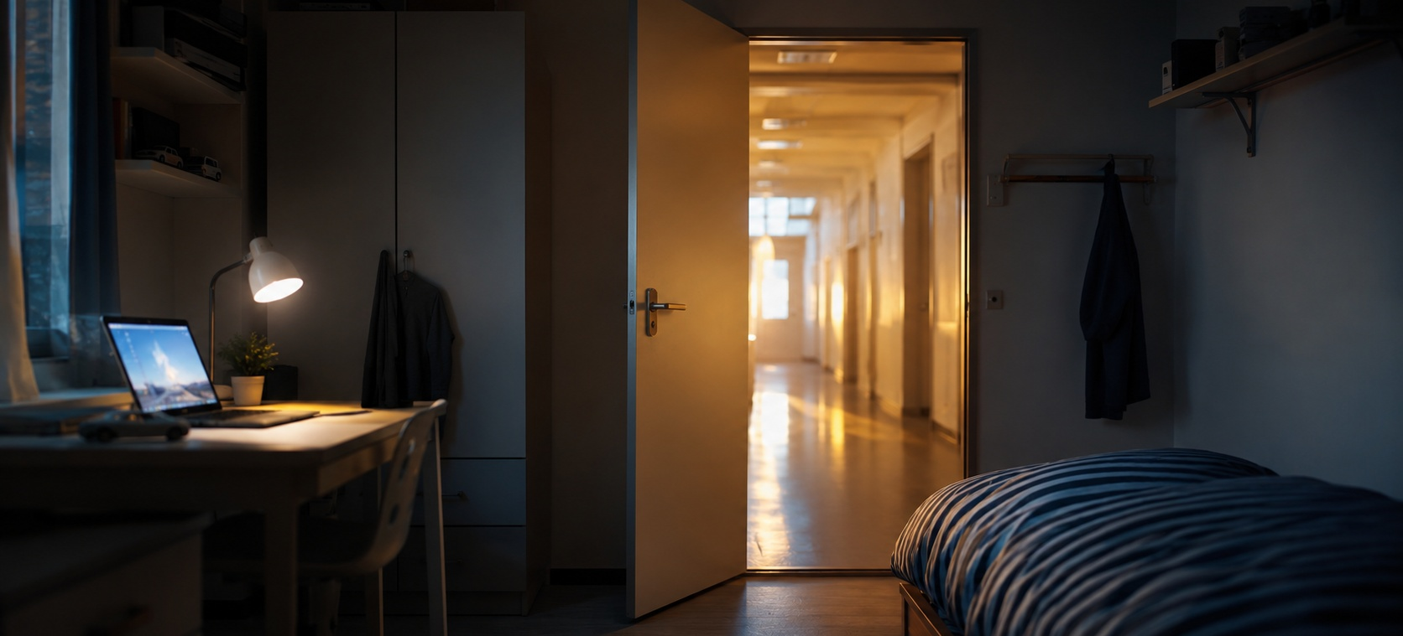
Beyond the Bedroom
A call to arms for the future of SEMH pupils
“The bedroom can become more than a room. It can become a quiet border around their world.”

A compassionate challenge to schools, families, commissioners and specialist partners.

01 | THE HUMAN STARTING POINT
The issue is not absence alone. It is narrowing worlds.
Since Covid, many schools and families have had to adapt to patterns that would once have felt exceptional: disrupted attendance, reduced routines, increased anxiety, greater reliance on screens, and more time spent at home. For some children, particularly those with SEMH needs, autism, trauma, anxiety or previous negative experiences of school, the bedroom can become more than a room. It can become a refuge, a control centre, a hiding place and, over time, a quiet border around their world. Professionals now have a name for this pattern, emotionally based school avoidance, but the label matters less than what it describes: a child who has quietly decided that the world beyond the door is not safe to enter.
We must approach this with compassion, not blame. For many families, allowing a child to stay in their room or engage mainly online may have felt like the least harmful option at the time. It may have reduced conflict, prevented escalation or provided some sense of safety. Parents and carers are often doing their best in circumstances that are emotionally exhausting and complex.
Care also requires honesty.

But care also requires honesty.
Lost learning hours are not neutral. When children miss significant time in school, they do not only miss lessons. They miss practice in relationships, routines, communication, resilience, independence, movement, reading, problem solving, confidence and belonging. These are not soft extras. They are the building blocks of adulthood.
relationships | routines | communication | resilience | independence
movement | reading | problem solving | confidence | belonging

02 | THE ATTENDANCE PICTURE
The scale is national. The impact is personal.
The latest Department for Education attendance data reinforces the scale of the challenge. The DfE's attendance release for the 2025/26 academic year up to 1 May 2026 shows absence in state-funded special schools at 12.90% year to date, compared with 5.11% in state-funded primary schools and 8.18% in state-funded secondary schools. In the week commencing 27 April 2026, absence in state-funded special schools was 12.51%. The DfE also notes that these national figures are estimates and may change as registers are updated. (Explore Education Statistics)
Absence rates, year to date up to 1 May 2026
Primary schools | █████████ | 5.11%
Secondary schools | ███████████████ | 8.18%
Special schools | ███████████████████████ | 12.90%
There are now around 170,000 pupils in state-funded and non-maintained special schools in England. Applied cautiously, a 12.90% absence rate is equivalent to around 22,000 pupil places worth of missed sessions across that population. This should not be read as 22,000 individual pupils absent every day, but it gives a stark sense of scale. (Explore Education Statistics)
These figures describe special schools as a whole, covering the full range of need they serve. When we narrow the lens to SEMH specifically, the picture sharpens rather than softens. Independent analysis of Department for Education data by the Centre for Social Justice found that around four in ten pupils with social, emotional and mental health needs were persistently absent, more than double the rate for pupils with no identified special educational need. The same analysis found severe absence running at nearly five times the rate for pupils with an Education, Health and Care Plan compared with those who have no identified SEN. This is not an adjacent statistic borrowed to make a point look bigger. It is the precise shape of the problem this essay is written about.
This is why the issue cannot be left to individual families, individual schools or individual pupils to solve alone. It requires a collective response.
This is not an adjacent statistic borrowed to make a point look bigger. It is the precise shape of the problem.

03 | WHAT PROVISION MUST DO
Expectation matters, but it cannot stand alone.
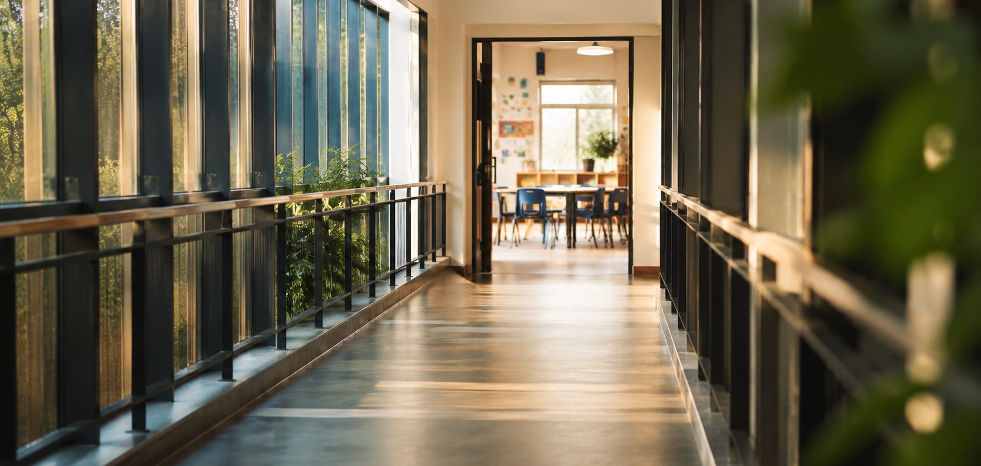
Parents need to trust that schools are not judging them. Schools need to understand the realities families are managing. Local authorities, commissioners, clinicians, therapists, social care partners and specialist providers need to work together with greater urgency and coherence. Attendance is not simply a compliance measure. It is a safeguarding, learning, social and future life issue.
At the same time, schools must resist the temptation to speak about attendance as though the only answer is firmer expectation. Expectation matters, but it cannot stand alone. In specialist schools, we have a responsibility to make learning more accessible, more meaningful, more creative and more inviting. We cannot simply demand that pupils attend. We must build provision that gives them reasons to return.
That means classrooms where pupils feel emotionally safe enough to try. It means skilled adults who understand regulation, trauma and relationship based practice. It means literacy, life skills, therapeutic support, enrichment, careers, outdoor learning, creativity, accreditation and practical pathways being used intelligently to widen pupils' worlds. Learning should not feel like a trapdoor. It should feel like a bridge.
Learning should not feel like a trapdoor. It should feel like a bridge.

04 | JUDGING AMBITION PROPERLY
Headline data cannot tell the full story.
Regulatory and sector frameworks also have a vital role. Ofsted, ISI and wider independent school accountability bodies should rightly examine attendance, outcomes and quality. But in specialist settings, they must also examine context. Headline data alone cannot tell the full story. The more important questions are: what are pupils' starting points, what barriers are being addressed, how effectively are resources being used, how well are families being engaged, and what progress is being made over time?
This does not mean lowering ambition. It means judging ambition properly.
For SEMH pupils, success may begin with leaving the bedroom, entering the building, tolerating a trusted adult, completing ten minutes of learning, repairing a relationship, reading aloud for the first time in months, attending a work related visit or beginning to believe that school can be a place of possibility rather than threat. These steps matter. They are not excuses. They are evidence of movement.
1. leaving the bedroom | 2. entering the building
3. tolerating a trusted adult | 4. ten minutes of learning
5. repairing a relationship | 6. reading aloud again
7. a work related visit | 8. believing school can be possible
The challenge before us is urgent. We cannot allow a generation of vulnerable pupils to drift into adulthood digitally connected but socially isolated, entertained but underprepared, protected from short term distress but denied long term opportunity.

05 | THE COLLECTIVE RESPONSE
Good practice should travel.

This is a call to arms, but it is also an invitation.
We need schools, families, commissioners, inspectors, clinicians and specialist providers to share what works. We need to be honest about what is not working. We need to learn from settings that are rebuilding attendance, restoring trust, strengthening routines and making learning feel worth the effort again. This is achievable. I have watched a single school's careers offer grow into a shared forum spanning several schools, simply because people chose to open the filing cabinet rather than guard it. Attendance deserves the same ambition. Good practice should not sit quietly in one school's filing cabinet. It should travel.
Our shared aim must be simple and bold: fuller, safer, more connected and more purposeful lives.

Our shared aim must be simple and bold: to help SEMH pupils build lives that are fuller, safer, more connected and more purposeful.
This is not about blaming families or excusing schools. It is about shared responsibility. Comfort must not quietly become confinement. Lost learning must not become lost opportunity. Specialist education must be judged, supported and strengthened by how well it turns complex starting points into meaningful progress.
And that work belongs to all of us.
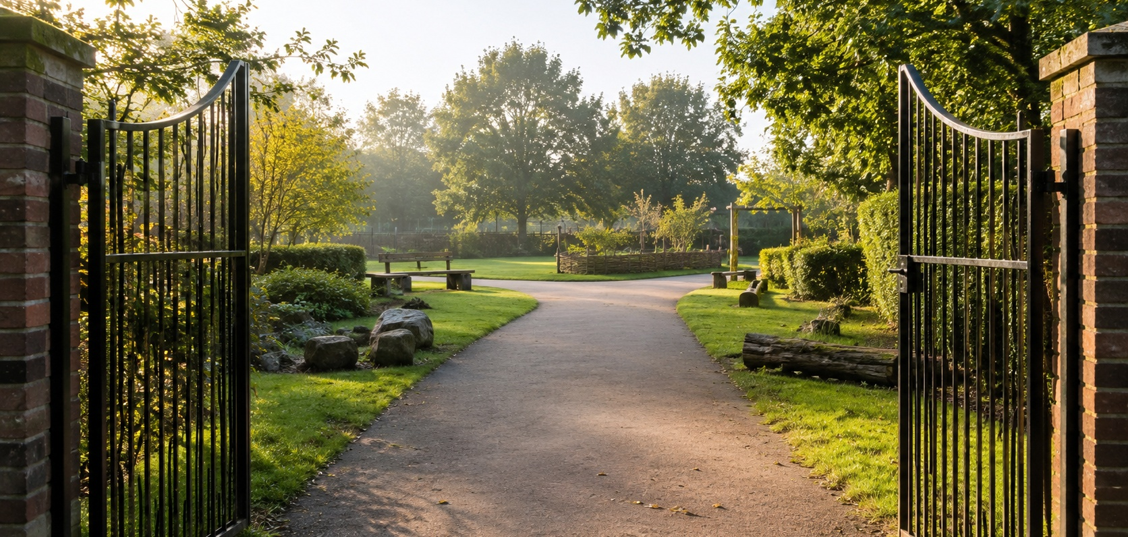
And that work belongs to all of us.

